Python Modules, Classes, Objects and Inheritance

Contents

Python Modules and OO Concepts 3

Is a class library an API? 3

Python Modules 3

Python Classes and Objects 3

Python Inheritance 3

References 5

5 Examples of Excellent API Documentation (and Why We Think So) 5

Framework vs Library vs Platform vs API vs SDK vs Toolkits vs IDE 5

# Python Modules and OO Concepts

## Is a class library an API?

An API is the way you access a library (or any set of classes). In object-oriented programming , a class library is a collection of prewritten class es or coded templates, any of which can be specified and used by a programmer when developing an application program. you could use a library in a variety of projects.

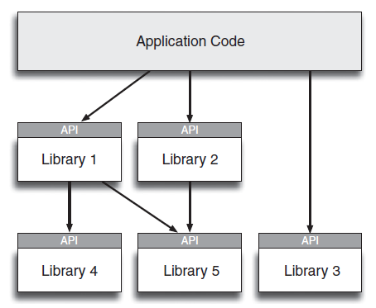

# Python Modules

<https://www.w3schools.com/python/python_modules.asp>

# Python Classes and Objects

<https://www.w3schools.com/python/python_classes.asp>

# Python Inheritance

<https://www.w3schools.com/python/python_inheritance.asp>

# References

### [5 Examples of Excellent API Documentation (and Why We Think So)](https://nordicapis.com/5-examples-of-excellent-api-documentation/)

### [Framework vs Library vs Platform vs API vs SDK vs Toolkits vs IDE](https://shashvatshukla.medium.com/framework-vs-library-vs-platform-vs-api-vs-sdk-vs-toolkits-vs-ide-50a9473999db)